**#Find the Min Max Sum Average of given N Numbers without using array**

Note: -1 will be terminated the input

Input:

10 20 30 40 50 -1

Output:

Min = 10

Max = 50

Sum = 150

Average = 30.000000

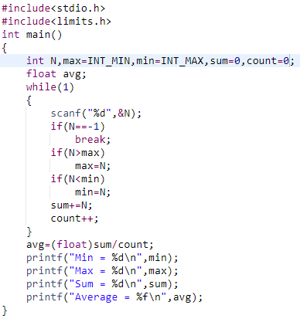

**#Conversion Decimal to Binary,Hexadecimal,Octal**

Input:

15

Output:

Decimal->15

Binary->01111

Octal->17

Hexadecimal->F

#include <stdio.h>

int main()

{

int N,j,i;

scanf("%d",&N);

printf("\nDecimal->%i",N);

printf("\nBinary->");

for(i=4;i>=0;i--)

{

j=N>>i;

if(j & 1)

printf("1");

else

printf("0");

}

printf("\nOctal->%o",N);

printf("\nHexadecimal->%X",N);

return 0;

}

**#STRING**

One word →%s

One sentence →%[^\n]s

**Ascii value**

Upper case:65-90

Lower case:97-122

‘0’ - 48 ‘9’-57

**1.STRING LENGTH**

#include <stdio.h>

int strlenfunc(char str[])

{

int count=0;

while(str[count]!=NULL)

{

count++;

}

return count;

}

int main(void) {

char str[1000];

int n;

scanf("%[^\n]s",str);

n=strlenfunc(str);

printf("%d",n);

return 0;

}

//alter method

#include <stdio.h>

int main(void) {

char str[1000];

int n=0;

scanf("%[^\n]s",str);

for(n=0;str[n];n++);

printf("%d",n);

return 0;

}

**2.STRING CONCATATION**

#include <stdio.h>

int main(void) {

char str1[1000],str2[1000];

int i,j;

scanf("%s",str1);

scanf("%s",str2);

for (i = 0; str2[i];i++);

for (j = 0; str1[j];j++)

{

str2[i++] = str1[j];

}

str2[i] = '\0';

printf("%s",str2);

return 0;

}

**3.STRING THE CHARACTER PRESENT IN THE STRING**

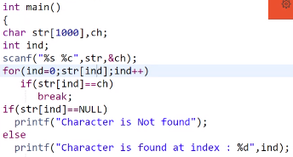

**4.SUBSTRING**

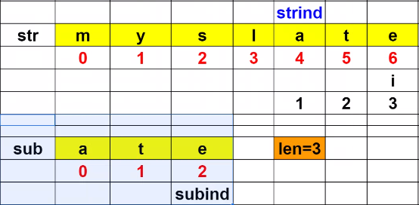

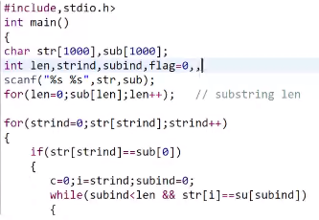

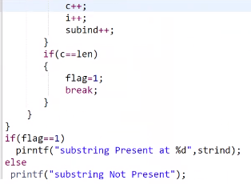

**5.STRING UPPER/LOWER**

#include <stdio.h>

int main(void) {

char str1[1000],str2[1000];

int i,n;

scanf("%s",str1);

for(n=0;str1[n];n++);

for(i=0;i<n;i++)

{

str2[i]=str1[i]-32; //+32 for lower case

}

printf("%s",str2);

return 0;

}

**6.STRING REVERSE**

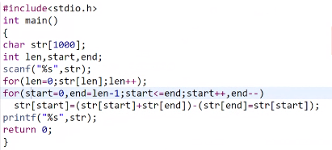

**7.REMOVE VOWEL**

